1. Installation

1.1. Download Visual Studio 2015 Community (https://www.visualstudio.com/en-us/products/free-developer-offers-vs.aspx) - it's free.
1.2. Download Inno Setup latest version (http://www.jrsoftware.org/isdl.php) - it's also free.

2. Build

2.1. Extract "EliteWork Desktop Tracker.zip".
2.2. Navigate to "EliteWork Desktop Tracker\EliteWork Desktop Tracker" folder.
2.3. Double click on "EliteWork Desktop Tracker.sln" file. It's Visual Studio 2015 Community main file for loading the project. Visual Studio 2015 Community must open.

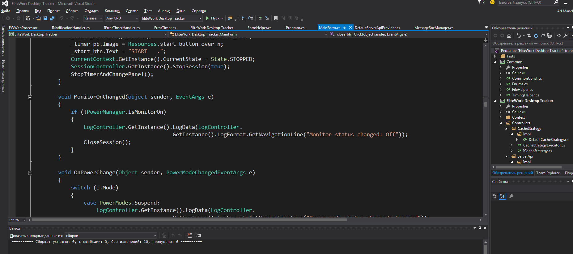
  - Just click F6 for start building the project.
  - The build outcomes to “EliteWork Desktop Tracker\EliteWork Desktop Tracker\bin\Release” directory.
  - Then go to “\EliteWork Desktop Tracker\InnoSetup”.
  - Double click “setup.iss”. Inno Setup IDE must open.

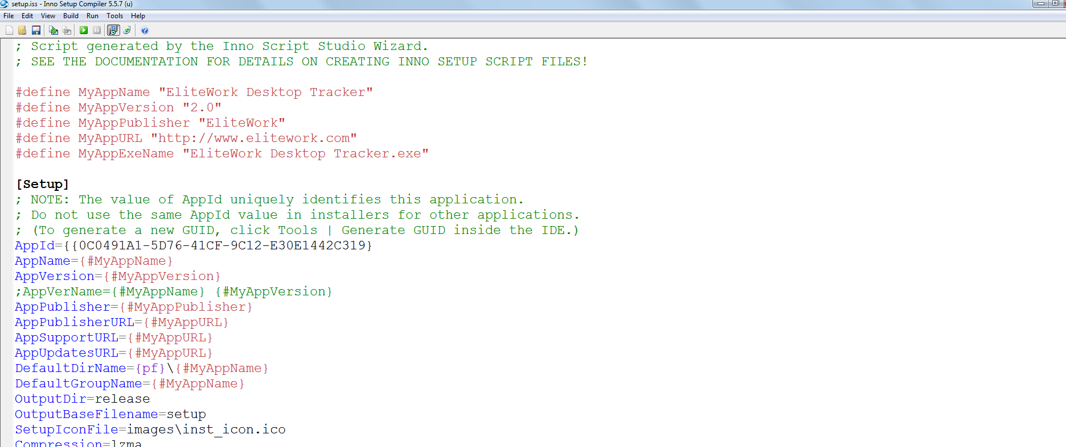

  - Click Ctrl+F9 for start building an Inno Setup output installer.
  - Navigate to “EliteWork Desktop Tracker\InnoSetup\release”. There is setup.exe file. It's the final app installer.

- Main Configuration Elements.

Almost all configuration is located in “EliteWork Desktop Tracker\Common\CommonConst.cs” C# file. Most important properties:

  - public static int SESSION_INTERVAL = 5 * 60 * 1000; - interval in which the app must make a screenshot.
  - public static int INTERNET_CONNECTION_TIMEOUT = 15 * 1000; - in 15 seconds of network silence the app decides that there are some problems with network.
  - public static double CURRENT_VERSION = 1.10; - current version of the app.
  - public static int BALLOON_DELAY = 2000; - the system tray balloon apears for 2 seconds
  - public static int LOG_INTERVAL = 30; - logs are saved for last 30 days now.

